# 

Nate Bennett

# CS 255 System Design Document Template

This template lays out all the different sections that you need to complete for Project Two. Each section has guidance to prompt your thinking. You will need to continually reference the interview transcript as you work to make sure that you are addressing your client’s needs. There is no required length for the final document. Instead the goal is to complete each section based on what your client’s needs are. Remove this note when you are finished, and replace all bracketed text with the relevant information.

## UML Diagrams

### UML Use Case Diagram

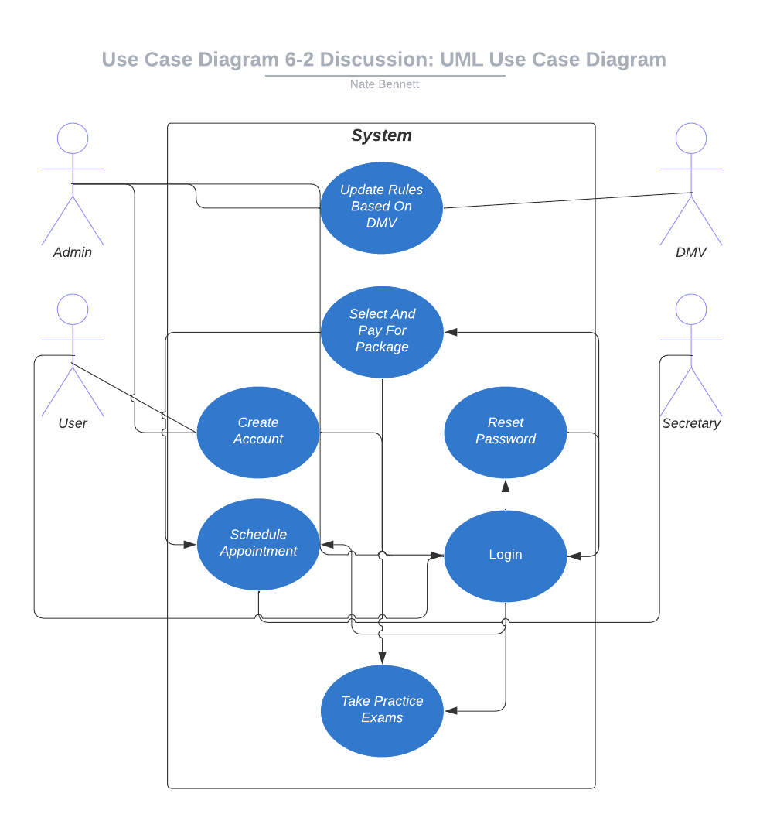

### UML Activity Diagrams

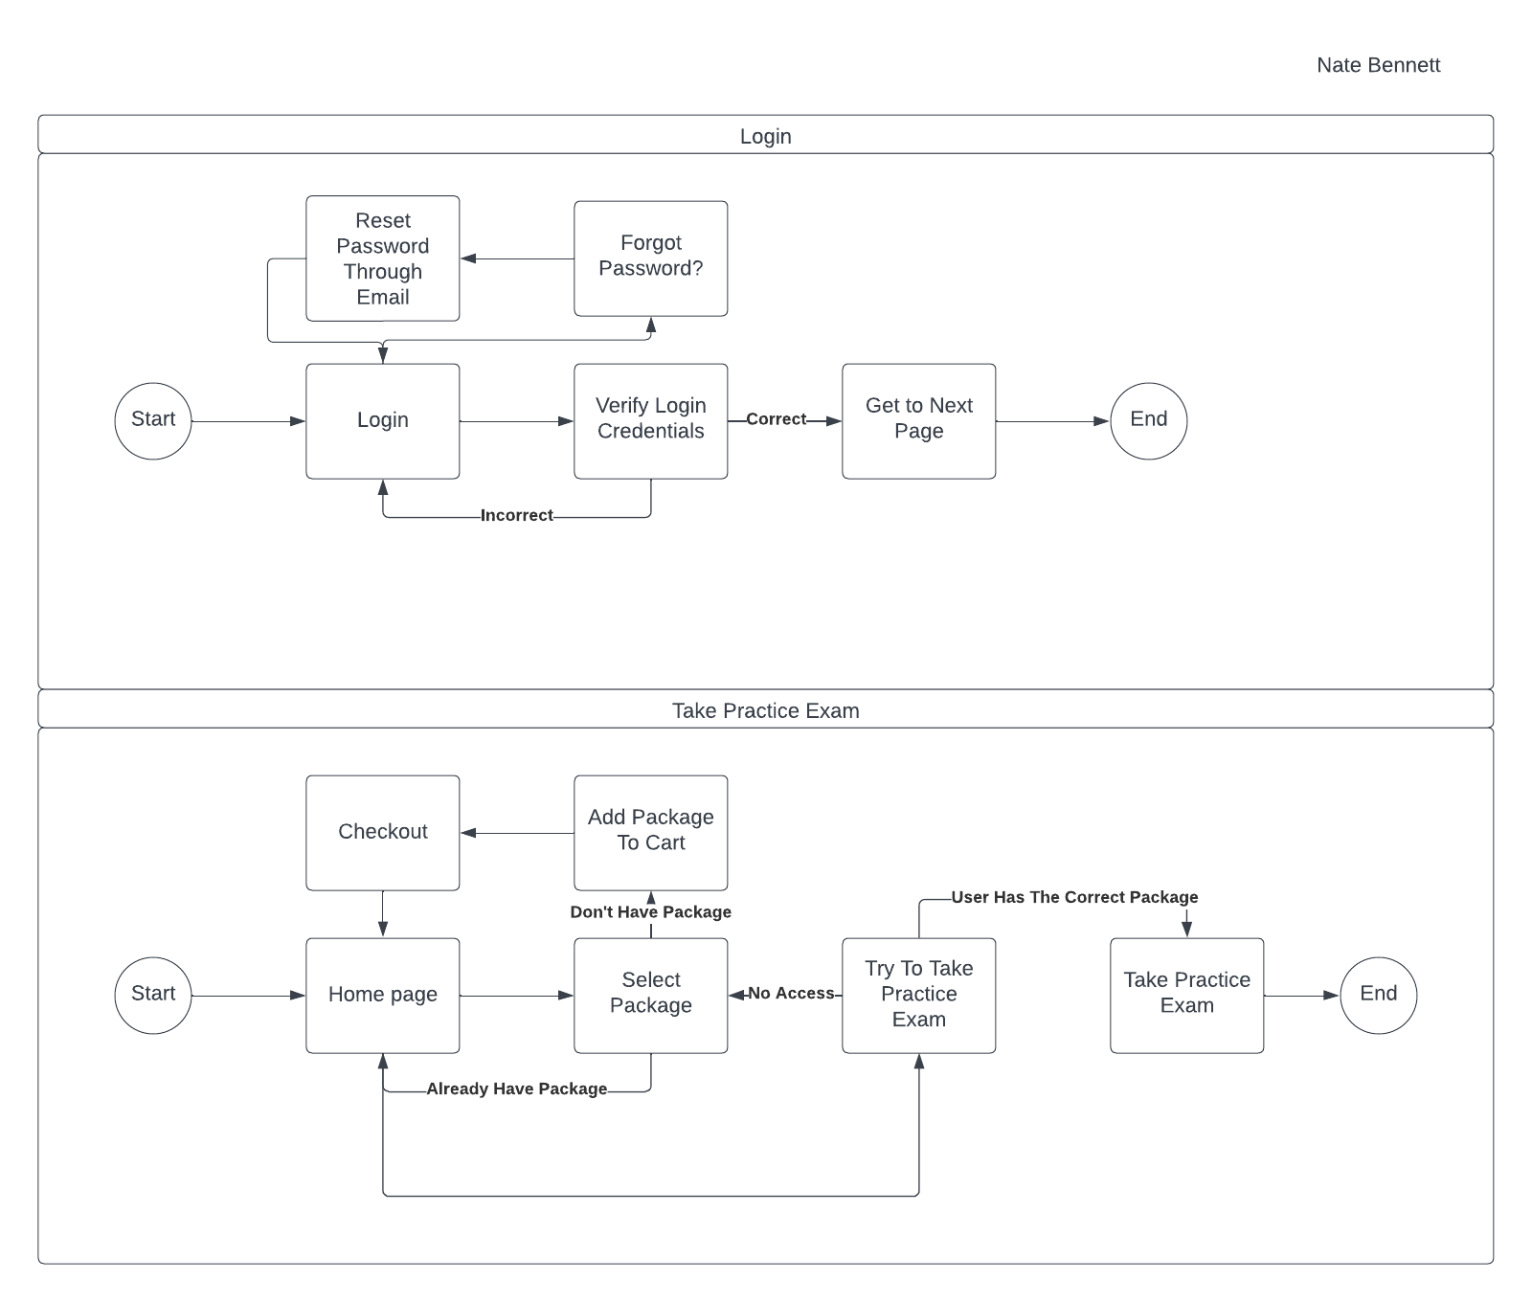

### UML Sequence Diagram

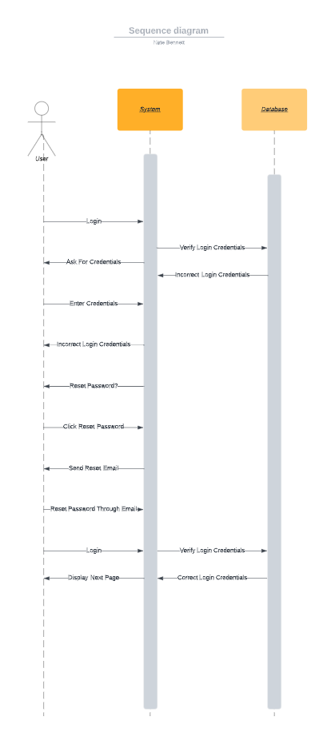

### UML Class Diagram

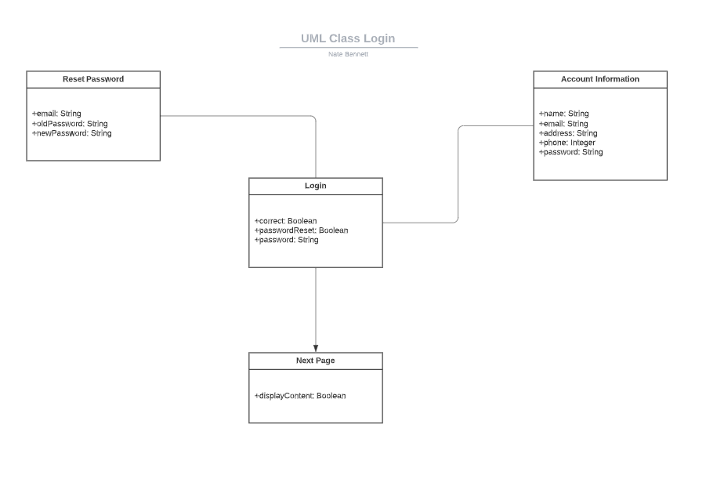

## Technical Requirements

*[Based on the diagrams you have created, describe the technical requirements of your system. These requirements should address the required hardware, software, tools, and infrastructure necessary for your system design.]*

The following are some technical requirements for the given system. In this scenario, the system is for the client, DriverPass. A technical requirement for hardware, can be servers that might host the application. For software, the system should have email integration for any potential password resets, a payment system, and could use various development frameworks. A tool that could be helpful for development would be an IDE. Reliability, scalability, and performance are other things to consider during development.